
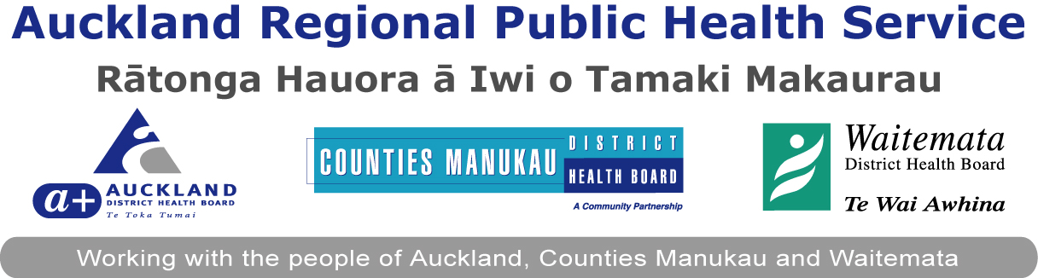

MEMORANDUM OF UNDERSTANDING

- Parties

Hapai Te Hauora Tapui
and
Auckland Regional Public Health Service

- Purpose

This Memorandum of Understanding (MOU) specifies the Partnership between Hapai Te Hauora Tapui and Auckland Regional Public Health Service – an operating unit of Auckland District Health Board. Both parties are committed to enhancing an environment of responsiveness to the Treaty of Waitangi partnership locally, regionally and nationally. This Memorandum of Understanding (MOU) provides the guiding relationship principles between the two parties, in the intention to achieve improved public health outcomes of all Maori who reside in the Auckland Region.

- Objectives

  - To achieve improvement in the provision and delivery of core Public Health services for Maori residing in the Auckland Region.
  - To provide and share opportunities for Hapai Te Hauora Tapui staff to access training provided by the Auckland Regional Public Health Service, and Auckland Regional Public Health staff to access training provided by Hapai Te Hauora Tapui
3. To develop partnerships/collaboration opportunities to meet objective one.

- Relationship Principles

- That the Treaty of Waitangi is recognised as a living document offering suitable frame work to consider planning and delivery of Health Services encompassing the principles of;

PARTICIPATION To ensure Maori participation in decision making, planning and the development of effective services

PARTNERSHIP - An ongoing relationship between the
crown and/or its agencies and Maori.
PROTECTION - To actively protect and promote Maori
Health so that Maori enjoy the same level of health as non Maori.

- To work together in a way that honours and respects the dignity of each other and maintains the integrity of each organisation
- To maintain the integrity of Maori Public Health, and Public Health within the health sector
- To work co-operatively and collaboratively to support the achievement of Public Health outcomes across the Auckland region.
- To acknowledge and work in such a manner that supports each other to achieve their own organisational objectives

- Roles and Responsibilities

Both parties declare and agree to the following

- That both parties will work together on project/s to improve the health of Maori living in the Auckland Region.
- That Auckland Regional Public Health and Hapai Te Hauora Tapui are committed to building their relationship in a Spirit of friendship and cooperation.
- That Auckland Regional Public Health acknowledges that Hapai Te Hauora Tapui maintains their own mana within their boundaries.
- Hapai Te Hauora Tapui acknowledges that Auckland Regional Public Health Service is bound by legislation that prescribes its powers and functions.
- That the nature of this partnership stems from the legacy of the Treaty of Waitangi.

Hapai Te Hauora Tapui agrees to:

- Provide Maori Public Health Leadership, through its Maori framework for Public health and health promotion.
- Work towards reducing inequalities by providing strong advocacy and promotion of Maori issues within the Auckland region.
- Provide training opportunities that support Maori public health and health promotion.

Auckland Regional Public Health Service agrees to:

- Work with Hapai to provide opportunities for Public health leadership.
- Share public health knowledge, resources, skills and training, opportunities to attain the desired outcome.

- Agreement

The parties agree:
- To Respect and value the knowledge, experience and advice of the other party.
- To inform, discuss and attempt to reach agreement on key issues pertinent to Maori in the Auckland Region.
- To acknowledge and respect the accountabilities of each party in the planning and decision-making processes.
- To respect and honour the right of each organisation to maintain its business autonomy.
- To communicate in an open and transparent manner, including reporting.

- Problem Resolution

All unresolved disputes and differences between the parties, in relation to the interpretation or performance of this MOU would be directed in the first instance to the CEO of Hapai Te Hauora Tapui and the Regional Manager of Auckland Regional Public Health Service. Both these positions will then enter into discussions to resolve the issue/s.

- Variation

This Memorandum of Understanding will only be modified by the written agreement and signed consent of persons authorised to sign on behalf of each party.

- Review

This Memorandum will be reviewed annually by those people with designated authority from Hapai Te Hauora Tapui and Auckland Regional Public Health Service.

- Term

This Memorandum will terminate when either party advises the other that in their view the Memorandum has reached the end of its useful life in respect to the strategic priorities set down under clause 2 and the strategic objectives set down under clause 3 of this Memorandum.

- Effective Date

This agreement will come into force on the date of signing by Hapai Te Hauora Tapui Trustees and Auckland Regional Public Health Service.

Signed: Date:
Name:
Designated Postion:
Hapai Te Hauora Tapui

Signed: Date:
Name:
Designated Position:
Auckland District Health Board
Auckland Regional Public Health Service

